[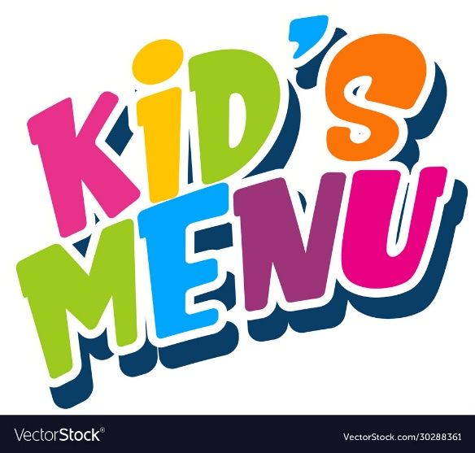](https://www.google.co.uk/url?sa=i&url=https%3A%2F%2Fwww.vectorstock.com%2Froyalty-free-vector%2Ffont-design-for-word-kids-menu-on-white-background-vector-30288361&psig=AOvVaw1b7PuoyLqJXZE98aKXW-yq&ust=1633082500443000&source=images&cd=vfe&ved=0CAYQjRxqFwoTCMiC6cq4pvMCFQAAAAAdAAAAABAe)**To Start your Day...** Graphical user interface, text, application
A selection of freshly baked pastries. **Prices Start From** …… **£1.75**  
  
**On Toast**   
Served with a choice of white, granary or gluten free bread. (1 slice).   
Kids buttered toast …… **95p**  
Kids Baked Beans …… **£1.90**  
Kids Scrambled Eggs (1 Egg) …… **£2.05**  
  
**All Day Breakfast**

All food is served until 3pm Monday – Saturday.

Prices include VAT, at the current rate of 20%.

**Kids Hub breakfast**  …… **£4.65**  
(1 rasher bacon, 1 sausage, 1 fried egg,   
baked beans, 1 slice buttered toast)

**Kids Vegetarian/Vegan Breakfast** …… **£4.30**  
(1 vegan sausage, 1 fried egg, hash brown, baked beans, 1 slice buttered toast)

**No egg on vegan bfast, extra hashbrown**

**Sandwiches**

Served with a choice of white, granary or gluten  
free bread with tomato & cucumber pieces.

Ham …… **£3.75**

Cheese …… **£3.95**  
Kids Lunch Bag …… **£6.25**  
(Ham or cheese sandwich, Fruit Shoot, Pom Bears, YoYo Bear, tomato & cucumber)

**Jacket Potatoes** (from 12pm)

**Food Allergens and Intolerances**

**Our food contains allergens.   
Please speak to a member of our team who’ll be able to help you.**

Half a jacket potato served with some tomato and cucumber.   
Baked Beans …… **£2.35**  
Cheese …… **£2.85**  
Cheese & Beans …… **£3.40**

Tuna …… **£3.75**